EE 506/CS 513

Introduction to Local and Wide Area Networks

Take-Home Final Examination

July 25, 2009

Due: Beginning of Class on Tuesday, July 28, 2009

Open Book

Open Notes

Name:__________________________________________________________________

There are eleven questions in this examination, and most problems are weighted equally at nine points. You must complete all eleven questions correctly to obtain full credit for the examination.

- Polynomial codes are typically used for the detection of transmission errors in computer networks. Consider a polynomial code which is based on the generator polynomial G(X) = X⁵ + X³ + X² + 1.

- Given the message polynomial M(X) = X¹² + X¹⁰ + X⁸ + X⁵ + X² + 1, compute the corresponding valid code polynomial T(X). (5 points)

- What error patterns can be detected by this generator polynomial, and what fraction of errors can be detected by this generator polynomial? (4 points)

- A channel has a data rate of 64 kbps and a propagation delay of 20 msec. For what range of frames sizes does a stop-and-wait protocol have an efficiency of at least 50%?
(9 points)

- Consider the Go-Back-N and Selective Repeat sliding window protocols given a noise-less (error-free) channel. The frame size is 1000 bits, headers are short and ACKs are always piggybacked. What is the optimal window size that will achieve maximum channel utilization for these protocols over a 64 kbps satellite channel with a round-trip delay time of 0.54 seconds, and how many sequence bits are required by each protocol to achieve this utilization? (9 points)

- In the network shown below, frames are generated at Node A and sent to Node C through Node B. Nodes B and C acknowledge each data frame immediately upon receipt to Nodes A and B, respectively. The channel data rate between Nodes A and B is 100 kbps. The lines between each pair of nodes are full-duplex, and the propagation delay for each line is 10 μsec/mile. All data frames are 1000 bits long and ACKs are separate frames of negligible length. A sliding window protocol with a window size of 3 is used between Nodes A and B, and a stop-and-wait protocol is used between Nodes B and C. All lines are error-free and no frames can be lost.

Determine the minimum data rate required between Nodes B and C so that the buffers of node B are not flooded. (9 points)

Hint: The buffers of node B will not be flooded if the average number of frames entering and leaving Node B are equal over a long time interval (at steady-state).
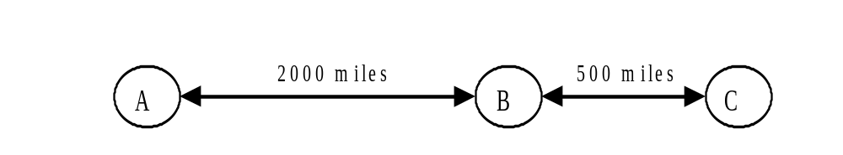

5. Ten thousand airline reservation stations are competing for the use of a single slotted ALOHA channel. The average station makes 18 requests/hour and a slot is 125 μsec in duration. What is the approximate total channel load and resulting throughput?
(9 points)

6. Consider designing a 1 km-long, 1 Gbps LAN which uses CSMA/CD and has a propagation speed of 200 m/μsec. What is the minimum frame size and the optimal channel efficiency that can be achieved using this frame size? (9 points)

7. Consider a CSMA/CD LAN with N independent stations. The probability that a station will transmit on an interference interval when given the opportunity is p.

- Derive a formula for the probability P(A) that one and only one station will transmit on an interference interval. (5 points)

- Compute the value of the probability p which maximizes the value of P(A), thereby achieving maximum throughput for this LAN. (5 points)

8. Assume that the bridges shown below in Figure 4-42 in Tanenbaum are transparent bridges, and that all stations have sent and received frames to/from all other stations. Construct the bridge tables for both bridges. (9 points)

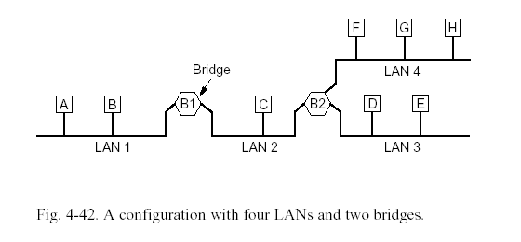
9. Consider the network shown below from Figure 5-13 in Tanenbaum. The numbers shown for each link are the delays between nearest neighbors for that link. Apply Dijkstra’s algorithm to this network starting at node A, and label each node with the shortest path route to node A using the same label techniques shown in Figure 5-7 in Tanenbaum.
(9 points)

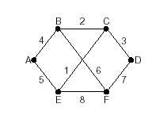

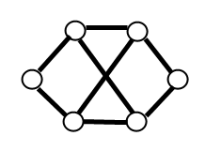
10. An IP network router uses a token bucket scheme for traffic shaping. A new token is put into the bucket every 10 μsec. Assume that the packet size (including the header) for all traffic through this router is 1000 Bytes, and the size of each header is 20 Bytes. What is the maximum sustainable net data rate that the router can achieve not including IP protocol overhead? (9 points)

11. A TCP entity opens a new connection and uses Jacobson’s slow start initialization process with dynamic window sizing to transmit segments to its peer. The congestion window size reaches a value of 18 when a timeout occurs. Assuming that all subsequent transmission bursts of segments are received successfully and the sending entity always has segments to send within the currently available window size, how big will the congestion window size be if the next four transmission bursts are received and acknowledged successfully?
(9 points)

